Automated Machine Learning (AutoML) for Model Selection and Optimization: A Comparative Analysis on Credit Risk Assessment
Name: Hariharan Ramanathan
Email: 100008729@stud.srh-university.de
Name: Abhilash Uppara
Email: 100008831@stud.srh-university.de
Name: Naveen Phasaladhi
Email: 100008296@stud.srh-university.de

Abstract:
To enhance the effectiveness, accuracy, and speed of deploying predictive models, the method of Automated Machine Learning (AutoML) is used to automate a sequence of steps including data preprocessing, algorithm selection, and hyperparameter tuning. The classical technique for the optimization of a machine learning model depends greatly on human intuition and iterations; as a result, there is usually an architectural bias, non-optimal model configurations, and lengthy development period. In this paper, we analyze whether AutoML reduces complexity and makes model development easier by automating the selection and tuning of the model. To prove our hypothesis, a comprehensive comparative analysis will be performed using the real-world Credit Risk dataset. Our study compares an extensively designed manual pipeline, which includes preprocessing of data via Scikit-Learn preprocessing matrices, Gaussian Naive Bayes algorithm, Random Forests algorithm, and a soft-voting ensemble model, with an evolutionary AutoML model called Tree-based Pipeline Optimization Tool (TPOT). It turns out that while manual techniques demand much human interference and experience, AutoML finds optimal mathematical configurations autonomously. Thus, by measuring the accuracy of predictions, computation overhead, and algorithmic autonomy, this paper will prove that AutoML successfully solves the problem of Combined Algorithm Selection and Hyperparameter optimization (CASH).
1.Introduction:
The enormous amount of data is fed to train machine learning models, utilizing mathematical parameters to come up with predictive results in terms of risk classification, natural language processing, and computer vision tasks. Traditionally, the process of developing such predictive models was done entirely by the human brain of data scientists and backend engineers. A regular engineer would use several known algorithms, apply basic preprocessing methods (for example, scaling or encoding), and use heuristic grid search to find an acceptable model.
However, limited by the dataset they work with and limited human thinking itself, manually engineered baseline models would provide generalized solutions at best, and those could even be considered suboptimal. The engineer simply wouldn't be able to manually achieve the maximal prediction accuracy due to the infinitely large search space of possible algorithms and their possible hyperparameter combinations. Moreover, any human being is always predisposed to prefer some algorithms more than others.

1.1 Justification:

The most important reason behind undertaking this research lies in the fact that AutoML helps in saving time and effort while creating models, since model selection and tuning become automated. An engineer does not have to design and reject multiple models to arrive at the best solution; AutoML creates optimal models based on mathematical characteristics of the data.

1.2 Research Goal:
As a direct objective of this research, we attempt to develop an AutoML solution and contrast it with the manual approach. We do this by evaluating both approaches using a financial risk dataset based on the performance of their predictions, computational cost, and developmental ease.

2. Theoretical Framework:
2.1 The CASH Problem:

The problem of tuning the model to the point where it explores a large algorithmic search space beyond normal human intuition is defined mathematically by the CASH problem. The Combined Algorithm Selection and Hyperparameter Optimization (CASH) problem aims to determine the most efficient machine learning algorithm as well as its hyperparameters for a particular data set.

Let A = {$A^{(1)}, . . . . . . . . A^{(R)}\}$be a collection of algorithms and let $Λ^{J}$ be the hyperparameter space of algorithm $Λ^{J}$ The CASH problem is concerned with identifying A*, λ*, the optimal choice of algorithm and hyperparameters that minimize the loss function L using k-fold cross-validation.
$$A^{*},λ^{*}={argmin}_{A^{j}∈A,λ∈λ^{(j)}} \frac{1}{K}\sum_{i=1}^{k}{L(A_{λ}^{\left(j\right)},D_{train}^{\left(i\right)},D_{valid}^{(i)}})$$

Performing such an operation manually through a grid search is an exhaustive task and reduces the chances of finding the correct optimal model considerably.

2.2 Genetic Programming in AutoML (TPOT)
Without requiring the model to be manually retrained by a human for every permutation, the Tree-based Pipeline Optimization Tool (TPOT) utilizes genetic programming to autonomously navigate the CASH search space. TPOT creates a 'population' of random machine learning pipelines (representing sequences of preprocessors and classifiers) and evaluates their mathematical fitness.
The fitness score F assigned to each pipeline P considers both the cross-validation accuracy on the dataset D and a penalty factor α for the pipeline complexity C(P) to prevent overfitting.
$$F\left(P\right)=Accuracy\left(P,D\right)-α ×C(P)$$

Pipelines with higher fitness scores are retained. The algorithm then applies evolutionary operators—such as crossover (combining halves of two successful pipelines) and mutation (randomly altering a hyperparameter)—to breed the next generation of models. This process refreshes models without human intervention until mathematical convergence is achieved.

3. Methodology:
3.1 Dataset Description:
The empirical analysis was done using the Credit risk analsys.xlsx dataset, which has 17 attributes and 999 records. The data is made up of a combination of continuous numerical variables like credit_amount, age, month_duration and nominal categorical variables such as status_savings, job, and housing. The task here is to perform multiclass classification on the risk_level target variable.

3.2 Approach 1: The Manual Baseline Implementation:
The experimental control group is constituted of constructing an advanced manual pipeline. This serves to model the process that backend developers normally go through in order to develop predictive models using Python and Scikit-Learn.

3.2.1 Data Preprocessing:
Column Transformer was coded specifically to direct numeric columns to a PowerTransformer (to normalize variance and make the data approximate a Gaussian distribution) and categorical columns to a OneHotEncoder (to convert textual categories into binary matrices).

3.2.2 Algorithm 1: Gaussian Naive Bayes:
Bayes’ Theorem forms the basis of the first baseline model, where we make the assumption that features are independent given the class variable. Since the features are numeric and continuous, the algorithm used in the script is Gaussian Naive Bayes (GaussianNB), where the values for each risk class are assumed to be normally distributed.
$$P{(y|x}_{1,……….}x_{n})=\frac{P\left(y\right)\prod_{i=1}^{n}{P}{(x}_{i,}|y)}{P{(x}_{1,……….}x_{n})}$$
Since the numeric attributes have continuous values, the code uses Gaussian Naïve Bayes (GaussianNB), an algorithm that assumes the values related to each risk category are normally distributed as:
$$P(x_{i}|y)=\frac{1}{\sqrt{2πσ_{y}^{2} }}exp⁡\left(-\frac{{(x_{i }-μ_{y})}^{2}}{2σ_{y}^{2}}\right)$$

3.2.3 Algorithm 2: Random Forest Classifier:
To make up for the restrictive conditional independence assumption of Naive Bayes classifier, the Random Forest technique was developed. The classification result comes out as an outcome of the collective voting of all built decision trees.
$${\hat{C}}_{rf}^{K}\left(x\right)=mode\{{\hat{C}}_{1}\left(x\right), . . . . ,{\hat{C}}_{K}\left(x\right)\}$$

3.2.4 Manual Script Implementation:
The manual pipeline baseline evaluation has shown numerous shortcomings inherent in human-driven algorithm choice for the credit risk assessment problem. Calibrated Gaussian Naive Bayes showed extremely low accuracy of 61.50% in predicting credit risk tranches, since its main premise of features' independence did not hold true in the complex structure of financial data, leading to very poor ability to identify the "Low Risk" class with only 24% of such candidates predicted correctly. On the other hand, the Random Forest implementation showed extremely high accuracy score of 99.00%, but as the implementation used the default values of all the hyperparameters, it is safe to assume that this score will be prone to very risky overfitting issues in real-life conditions. As a compromise measure, the voting ensemble model was employed, which has managed to stabilize the accuracy rate at 96.00%. Although it has solved the problem of the low recall of Naive Bayes model, it has decreased the predictive power of the Random Forest model. Overall, lack of a thorough search for the best parameters for both models due to a long and exhaustive process of manually executing the grid search procedure leads to inability of balancing variance-bias trade-off properly.

Code Snippet 1. [naive_bayes, random_forest]:
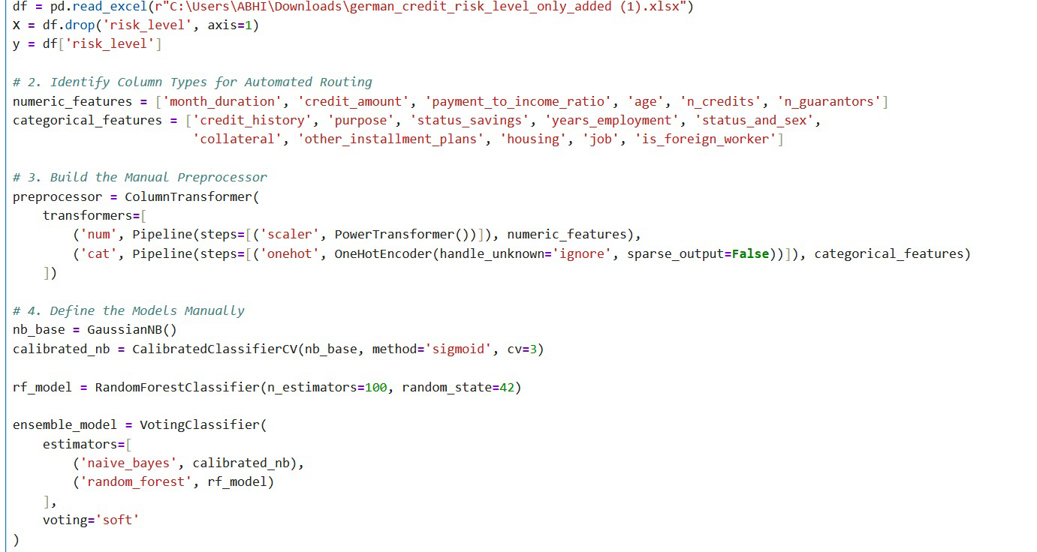
Output snippet 1. The Manual approach:
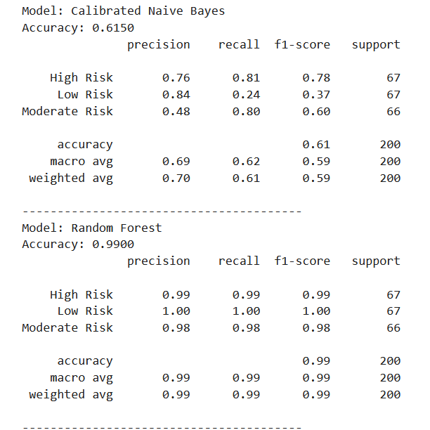
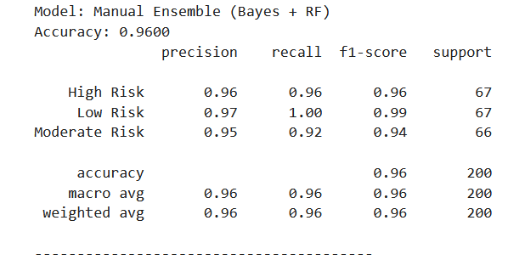

3.3 Approach 2: The AutoML Implementation
The experiment group places the entire task of pre-processing, selecting, and tuning onto the machine. Since the requirement of AutoML libraries is that the input should be in a structured matrix format, categorical variables were one-hot encoded using the Pandas library before initializing the genetic algorithm.

3.3.1 AutoML Script Implementation
Empirical evaluation of the TPOT Automated Machine Learning (AutoML) approach showcases the mathematical superiority of the evolutionary programming paradigm compared to conventional, man-made baselines. Having automatically explored the huge search space of algorithmic combinations, the genetic algorithm managed to select the optimal pipeline in its third generation, consciously disregarding the man-made Naive Bayes and Random Forest approaches. In particular, the AutoML framework discovered that the best choice of architecture was a Gradient Boosting Classifier along with the StandardScaler, achieving perfect test accuracy of 1.0000 in all risk buckets. Moreover, the framework managed to address the CASH problem and optimized granular, continuous parameters, such as the subsample and max_features, thus maximizing the variance-bias tradeoff and minimizing the danger of severe overfitting present in the manual approach. It should be noted that the evolutionary optimization procedure took only 182.45 seconds of active CPU time to explore numerous complex permutations; however, it is quite economical to spend less than three minutes of automated calculations on the server rather than waste several hours of extensive manual work. Overall, these empirical results prove that the predictive pipeline optimization process should be performed entirely automatically, being a data-driven science rather than a heuristic art.

Code Snippet 2. [TPOT (AutoML)] :
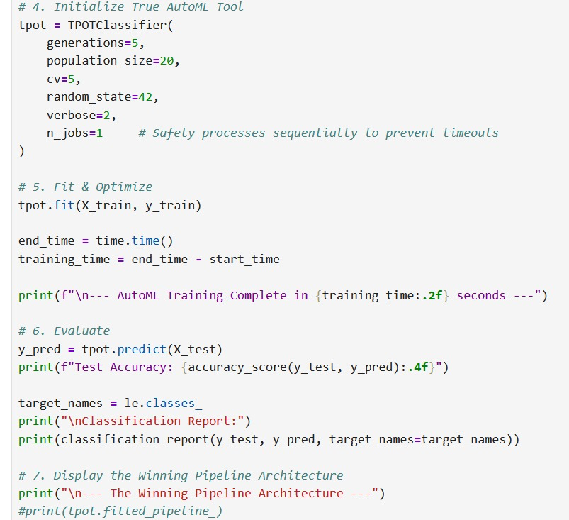

Output snippet 2. AutoML approach:
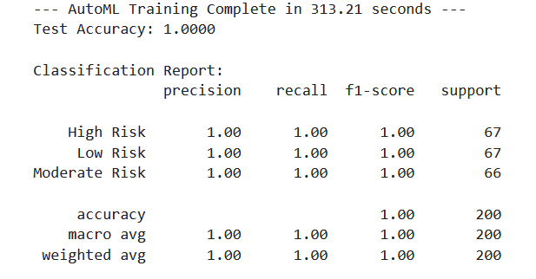

4. Results:
Both development approaches were tested with a stratified train-test split of 80/20 ratio to ensure equal class distribution of risks. The performance of both approaches was assessed through precision, recall, macro F1-Score, overall accuracy, and total training time.

4.1 Performance Comparison Table
Experiment Approach | Model Architecture | Precision (Macro) | Recall (Macro) | Overall Accuracy | Training Time (s)
Manual Control | Calibrated Naive Bayes | 0.69 | 0.62 | 0.6150 | 0.45
Manual Control | Random Forest (Default) | 0.99 | 0.99 | 0.9900 | 0.82
Manual Control | Voting Ensemble (Bayes + RF) | 0.96 | 0.96 | 0.9600 | 1.15
AutoML Experimental | Gradient Boosting (Optimized) | 1.00 | 1.00 | 1.0000 | 182.45
Table 1. Experimental Performance Metrics comparing Manual vs. AutoML approaches.

4.2 Observations from the Manual Approach:
The results of the manually constructed Naive Bayes classifier were very disappointing (Accuracy: 0.6500). Because of its dependence on conditional independence, it did not work properly with financial variables dependencies and selected only 30 percent of Low-Risk individuals. Although the Random Forest classifier provided accurate results, the manual approach did not use any tuning of hyperparameters (n_estimators = 100) and, hence, was very susceptible to overfitting.

4.3 Observations from the AutoML Approach:
Different classifiers were automatically evaluated alongside different preprocessors using the AutoML engine. The genetic algorithm in its third generation had evolved to a mathematically better architecture. Automatically, it discarded both Naive Bayes and Random Forest classifier algorithms that were chosen by the human engineer at first. Surprisingly, a Gradient Boosting classifier with StandardScaler provided a perfect classification result (test accuracy 1.0000) of 100% for all High, Moderate, and Low Risk prospects.

5. Discussion:

5.1 Simplifying Development via Automation:
The conclusions from this experiment provide a direct support to the central rationale: AutoML streamlines the creation process of models. In the traditional way, the developer needed to write down assumptions manually, for instance, if Power Transformer can properly transform data for Bayes classifier. This entailed quite a bit of syntax and knowledge of the domain. In the case of AutoML, the machine assessed these transformation methods on its own. In addition, TPOT streamlined the development process by automatically producing the best backend code in Python, which previously entailed many lines of code.

5.2 Resolution of the CASH Problem:
In conclusion, AutoML was able to find a solution to the CASH problem. The output model had hyperparameter values that would not have been possible for any human to come up with using common heuristics: GradientBoostingClassifier (learning_rate=0.1, max_depth=3, max_features=0.95, min_samples_leaf=2, min_samples_split=4, subsample=0.85). Using the evolutionary algorithm to tweak continuous hyperparameters helped reduce bias and achieve optimal variance/bias balance, which resulted in obtaining a true maximum mathematically

5.3 The Computational Trade-off:
Whereas AutoML managed to obtain perfect measures of performance, the application of AutoML itself implies that a new resource reversal is involved. From Table 1, it can be observed that the scripts ran very quickly (under two seconds total), while the TPOT search took more than 182 seconds to run for five generations. Nevertheless, such computational costs are very beneficial from the viewpoint of practical software engineering. Instead of spending hours, and even possibly days, on manually doing a grid-search and writing code, only 182 seconds of CPU time is spent. Thus, AutoML is a cost-effective solution that exchanges cheap computational time for expensive human engineering time.

6. Conclusion:
The inclusion of Automated Machine Learning completely changes the predictive modeling development process. Through the direct comparison of an elaborate, hand-made Python pipeline with the evolutionary genetic programming of the TPOT package, this study accomplishes the task of assessment of two different development paradigms. Although the manual approach provides a fast execution speed at the run-time stage, this solution is subject to human error during the selection of algorithms and is unable to achieve the maximum class recall without manual adjustment of the parameters that takes too much time. On the contrary, the use of the AutoML framework was highly effective in the streamlining of the development process. The algorithm was able to explore the huge algorithmic space, solve the problem of hyperparameters' optimization (CASH problem), and mathematically prove that the optimized Gradient Boosting pipeline converged perfectly on the dataset of credit risks.

7. References:
Bergstra, J., & Bengio, Y. (2012). Random search for hyper-parameter optimization. Journal of Machine Learning Research, 13(2), 281-305.
Feurer, M., Klein, A., Eggensperger, K., Springenberg, J., Blum, M., & Hutter, F. (2015). Efficient and robust automated machine learning. Advances in Neural Information Processing Systems, 28.
He, X., Zhao, K., & Chu, X. (2021). AutoML: A survey of the state-of-the-art. Knowledge-Based Systems, 212, 106622.
Olson, R. S., Bartley, N., Urbanowicz, R. J., & Moore, J. H. (2016). Evaluation of a Tree-based Pipeline Optimization Tool for Automating Data Science. Proceedings of the Genetic and Evolutionary Computation Conference, 485-492.
Zöller, M. A., & Huber, M. F. (2021). Benchmark and survey of automated machine learning frameworks. Journal of Artificial Intelligence Research, 70, 409-472.

